Q1:
import java.util.Scanner;
public class Radiator {
static int count = 0;
private String RadiatorID;
private boolean isON;
Radiator() {
Scanner sc1 = new Scanner(System.in);
System.out.println("Enter your Student ID:");
this.RadiatorID = sc1.nextLine();
count++;
isON = false;
}
public void heats(Room ROOM) {
isON = true;
System.out.printf("Radiator %d is on now. \n" ,count);
}
public String getRadiatorID() {
return RadiatorID;
}
void print() {
String numbers;
int realid;
numbers = getRadiatorID().replaceAll("[^0-9]", "");
realid = Integer.parseInt(numbers);
realid %= 1000;
realid += 15;
System.out.printf("Radiator Id %d: %03d\n", count, realid);
}
public static void main(String[] args) {
Scanner m = new Scanner(System.in);
System.out.println("NAME: M. Arham Hussain Khan\t\t" + "ID: 22k-4080");
System.out.println("Enter Room Name:");
String Rname = m.nextLine();
Room room = new Room(Rname);
Radiator rd1 = new Radiator();
rd1.print();
rd1.heats(room);
Radiator rd2 = new Radiator();
rd2.print();
rd2.heats(room);
System.out.println(room.isHeatedBy(rd1));
System.out.println(room.isHeatedBy(rd1));
System.out.println(room.isHeatedBy(rd2));
}
}
class Room {
private String roomName;
private int seatingCapacity,numRadiator;
private Radiator radiators[] = new Radiator[2];
Room(String rName){
seatingCapacity=12;
roomName = rName;
numRadiator = 0;
}
public String isHeatedBy(Radiator rad){
for(int i=0;i < numRadiator;i++){
if(radiators[i].getRadiatorID() == rad.getRadiatorID()){
return "Radiator Already added to the room.";
}
else if (numRadiator >=2 ){
return "Cannot add Radiator. Room has a maximum numbers of Radiators.";
}
}
radiators[numRadiator] = rad;
numRadiator++;
return "Radiator successfully added to room.";
}
}
OUTPUT:
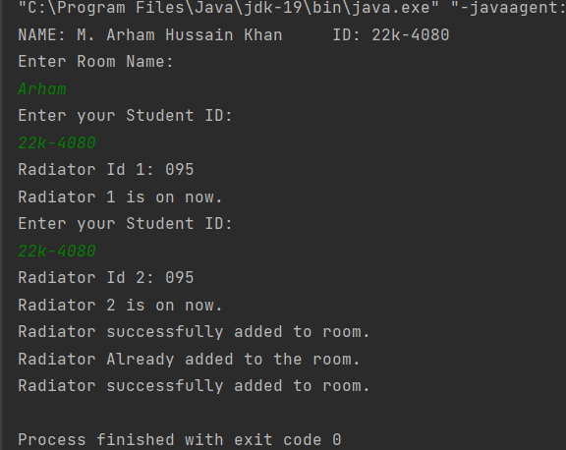

Q2:
import java.util.Scanner;
class DataScientist {
private int userID;
private String firstName, lastName;
private String highestEducation;
private int age;
private String Country;
private int noQuestions, noAnswers;
private static int ID = 0;
private static int Add = 15;
public DataScientist() {
assignId();
}
public DataScientist(String firstName, String lastName, String highestEducation, int age, String Country,
Admin ad) {
assignId();
this.firstName = firstName;
this.lastName = lastName;
this.highestEducation = highestEducation;
this.Country = Country;
this.age = age;
ad.AddUser();
}
public int assignId() {
int myID = ID % 1000;
this.userID = userID + Add;
Add += 15;
return myID;
}
public int getuserID() {
return this.userID;
}
public String getfirstName() {
return this.firstName;
}
public String gethighestEducation() {
return this.highestEducation;
}
public String getCountry() {
return this.Country;
}
public String getlastName() {
return this.lastName;
}
public int getage() {
return this.age;
}
public int getnoQuestions() {
return this.noQuestions;
}
public int getnoAnswers() {
return this.noAnswers;
}
public void setfirstName(String firstName) {
this.firstName = firstName;
}
public void setCountry(String Country) {
this.Country = Country;
}
public void setlastName(String lastName) {
this.lastName = lastName;
}
public void setage(int age) {
this.age = age;
}
public void AskQuestion() {
this.noQuestions++;
}
public void AnswerProblem() {
this.noAnswers++;
}
}
class Admin {
private int adminID;
private String firstName, lastName;
private int age;
private String Country;
private int noUsers;
private static int ID = 0;
private static int Add = 15;
public Admin() {
assignId();
}
public Admin(String firstName, String lastName, int age, String Country) {
assignId();
this.firstName = firstName;
this.lastName = lastName;
this.Country = Country;
this.age = age;
}
public int assignId() {
int myID = ID % 1000;
this.adminID = adminID + Add;
Add += 15;
return myID;
}
public int getadminID() {
return this.adminID;
}
public String getfirstName() {
return this.firstName;
}
public String getCountry() {
return this.Country;
}
public String getlastName() {
return this.lastName;
}
public int getage() {
return this.age;
}
public int TotalUser() {
return this.noUsers;
}
public void setfirstName(String firstName) {
this.firstName = firstName;
}
public void setCountry(String Country) {
this.Country = Country;
}
public void setlastName(String lastName) {
this.lastName = lastName;
}
public void setage(int age) {
this.age = age;
}
public void AddUser() {
this.noUsers++;
}
public static void main(String[] args) {
Scanner scanner = new Scanner(System.in);
System.out.println("NAME: M. Arham Hussain Khan\t\t" + "ID: 22k-4080");
System.out.print("Enter Last Digits of Your Student ID :- ");
ID = scanner.nextInt();
Admin newAdmin = new Admin("Admin", "Arham", 25, "Pakistan");
String firstName, lastName;
String highestEducation;
int age;
String Country;
System.out.print("\nEnter firstName :- ");
firstName = scanner.next();
System.out.print("\nEnter lastName :- ");
lastName = scanner.next();
System.out.print("\nEnter highestEducation :- ");
highestEducation = scanner.next();
System.out.print("\nEnter age :- ");
age = scanner.nextInt();
System.out.print("\nEnter Country :- ");
Country = scanner.next();
DataScientist scientist = new DataScientist(firstName, lastName, highestEducation, age, Country, newAdmin);
String q, a;
System.out.print("Ask a question :- ");
q = scanner.next();
scientist.AskQuestion();
System.out.println("Ask a Answer :- ");
a = scanner.next();
scientist.AnswerProblem();
System.out.print("No Data Scientist By Admin :- ");
System.out.print(newAdmin.TotalUser());
}
}

OUTPUT:
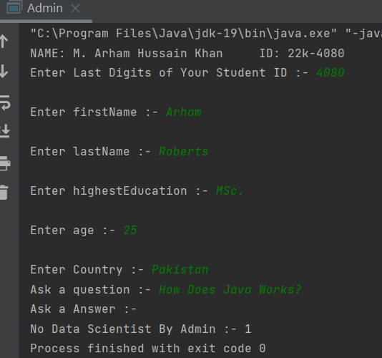
Q3:
import java.util.Scanner;
public class HeartRates {
private String ID;
private String firstName;
private int day;
private int month;
private int year;
private int currentYear;
public HeartRates(String id, String firstName, int day, int month, int year, int currentYear) {
this.ID = id;
this.firstName = firstName;
this.day = day;
this.month = month;
this.year = year;
this.currentYear = currentYear;
}
public String getID() {
return ID;
}
public String getFirstName() {
return firstName;
}
public int getDay() {
return day;
}
public int getMonth() {
return month;
}
public int getYear() {
return year;
}
public int getCurrentYear() {
return currentYear;
}
public int getAge() {
return currentYear - year;
}
public int getMaximumHeartRate() {
return 220 - getAge();
}
public float[] getTargetHeartRate() {
float[] range = new float[2];
range[0] = getMaximumHeartRate() * 0.5f;
range[1] = getMaximumHeartRate() * 0.85f;
return range;
}
public static void main(String[] args) {
Scanner scanner = new Scanner(System.in);
System.out.println("NAME: Arham Hussain\t\t\tROLL NUMBER: 22K-4080\n");
System.out.print("Enter your Student ID: ");
String id = scanner.nextLine();
System.out.print("Enter your name: ");
String name = scanner.nextLine();
System.out.println("Enter your Date of Birth:");
System.out.print("Day: ");
int day = scanner.nextInt();
System.out.print("Month: ");
int month = scanner.nextInt();
System.out.print("Year: ");
int year = scanner.nextInt();
System.out.print("Enter Current year: ");
int currentYear = scanner.nextInt();
HeartRates user_1 = new HeartRates(id, name, day, month, year, currentYear);
//display function
System.out.println("\n---------------------DETAILS---------------------\n");
System.out.println("ID: " + user_1.getID());
System.out.println("Name: " + user_1.getFirstName());
System.out.println("Date of Birth: " + user_1.getDay() + "/" + user_1.getMonth() + "/" + user_1.getYear());
System.out.println("Age: " + user_1.getAge());
System.out.println("Maximum Heart Rate: " + user_1.getMaximumHeartRate() + " bpm");
System.out.println("Target Heart Rate: " + user_1.getTargetHeartRate()[0] + " % to " + user_1.getTargetHeartRate()[1] + "%");
scanner.close();
}
}

OUTPUT:
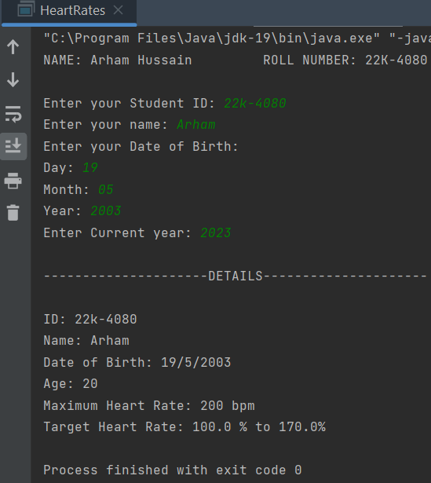
Q4:
import java.util.Scanner;
public class MovieTicketSystem {
public static void main(String[] args) {
Scanner m = new Scanner(System.in);
System.out.println("NAME: Arham Hussain\t\t\tROLL NUMBER: 22K-4080\n\n");
System.out.print("Enter Movie Name:");
String mv1 = m.nextLine();
System.out.println("Enter Show Time: ");
String slot1 = m.nextLine();
Movie movie = new Movie(mv1, slot1);
Ticket ticket1 = new Ticket("22k-4080", 5, 20);
ticket1.setStatusSold();
movie.display();
System.out.println();
ticket1.display();
}
}
class Movie {
private String movieName;
private String showTime;
// constructor
public Movie(String movieName, String showTime) {
this.movieName = movieName;
this.showTime = showTime;
}
// display
public void display() {
System.out.println("-----Movie Details------\n\n");
System.out.println("Movie Name: " + movieName);
System.out.println("Show time: " + showTime);
}
}
class Ticket {
private int rowNo, seatNumber, ticketID;
private boolean status;
// constructor
public Ticket(String id, int seatNumber, int rowNo) {
this.rowNo = rowNo;
this.seatNumber = seatNumber;
this.status = false;
this.ticketID = (id.charAt(5) - 48) + (id.charAt(4) - 48) * 10;
}
// getter
public boolean checkStatus() {
return status;
}
// setter
public void setStatusSold() {
status = true;
}
// display
public void display() {
System.out.println("\n\n---------- TICKET DETAILS ------------\n\n");
System.out.println("Row number: " + rowNo);
System.out.println("Seat Number: " + seatNumber);
System.out.println("Ticket ID: " + ticketID);
if (status)
System.out.println("Status: SOLD");
else
System.out.println("Status: NOT SOLD");
}
}

OUTPUT:
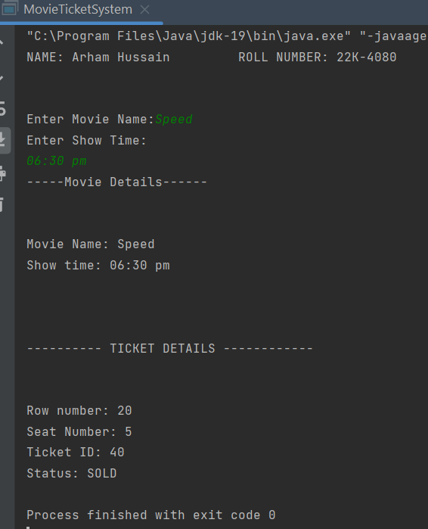

Q5:
import java.util.Scanner;
class User {
private String name;
private int age;
private int size;
private double height;
private char gen;
private int[] Id = new int[2];
private String brand;
public User() {}
public User(String name, int age, int size, double height, char gen, int[] Id, String brand) {
this.name = name;
this.age = age;
this.size = size;
this.height = height;
this.gen = gen;
this.Id[0] = Id[0];
this.Id[1] = Id[1];
this.brand = brand;
}
public String getName() {
return name;
}
public int getAge() {
return age;
}
public int getSize() {
return size;
}
public double getHeight() {
return height;
}
public char getGen() {
return gen;
}
public int[] getId() {
return Id;
}
public String getBrand() {
return brand;
}
public void setName(String name) {
this.name = name;
}
public void setAge(int age) {
this.age = age;
}
public void setSize(int size) {
this.size = size;
}
public void setHeight(double height) {
this.height = height;
}
public void setGen(char gen) {
this.gen = gen;
}
public void setId(int[] Id) {
this.Id[0] = Id[0];
this.Id[1] = Id[1];
}
public void setBrand(String brand) {
this.brand = brand;
}
}
public class Shoe {
private int size;
private int width;
private String brand;
private String demographic;
private String style;
private String color;
public Shoe() {
}
public Shoe(int size, String brand, User user, int width, String style, String color) {
this.size = size;
this.brand = brand;
setDemographic(user.getAge());
this.width = width;
this.style = style;
this.color = color;
}
public int getWidth() {
return width;
}
public String getStyle() {
return style;
}
public String getColor() {
return color;
}
public int getSize() {
return size;
}
public String getBrand() {
return brand;
}
public String getDemographic() {
return demographic;
}
public void setWidth(int width) {
this.width = width;
}
public void setStyle(String style) {
this.style = style;
}
public void setColor(String color) {
this.color = color;
}
public void setSize(int size) {
this.size = size;
}
public void setBrand(String brand) {
this.brand = brand;
}
public void setDemographic(String demographic) {
this.demographic = demographic;
}
public void setDemographic(int age) {
if (age >= 0 && age <= 2) {
demographic = "infant";
} else if (age >= 3 && age <= 5) {
demographic = "toddler";
} else if (age >= 10 && age <= 12) {
demographic = "child";
} else if (age >= 13 && age <= 19) {
demographic = "teenager";
} else if (age >= 19) {
demographic = "adult";
}
}
public static void bonus(User user, Shoe shoe) {
System.out.println("Name: " + user.getName());
System.out.println("Age: " + user.getAge());
System.out.println("Shoe size: " + user.getSize());
System.out.println("Height: " + user.getHeight());
System.out.println("Gen: " + user.getGen());
System.out.println("User ID: " + user.getId()[0] + "-" + user.getId()[1]);
System.out.println("Shoe size: " + shoe.getSize());
System.out.println("Brand: " + shoe.getBrand());
System.out.println("Demographic group: " + shoe.getDemographic());
}
public static void main(String[] args) {
User user = new User();
Shoe shoe = new Shoe();
Scanner scanner = new Scanner(System.in);
String input;
int option;
System.out.print("Enter your student ID (format: xxk-yyyy): ");
input = scanner.nextLine();
int[] Id = {
Integer.parseInt(input.substring(0, 2)), Integer.parseInt(input.substring(5))
};
user.setId(Id);
while (true) {
System.out.println("\nMenu");
System.out.println("1. Shoe information");
System.out.println("2. Update data");
System.out.println("3. Display data using getter functions");
System.out.println("4. Display data using bonus function");
System.out.println("5. Exit");
System.out.print("Enter option: ");
option = scanner.nextInt();
switch (option) {
case 1: {
String name, brand, demographic, style = "", color;
int age, size, width;
double height;
char gen;
System.out.println("\nEnter information:");
scanner.nextLine();
System.out.print("Name: ");
name = scanner.nextLine();
System.out.print("Age: ");
age = scanner.nextInt();
System.out.print("Shoe size: ");
size = scanner.nextInt();
System.out.print("Height (in meters): ");
height = scanner.nextDouble();
System.out.print("Gen (M/F): ");
gen = scanner.next().charAt(0);
scanner.nextLine();
System.out.println("\nEnter shoe information:");
System.out.print("Brand: ");
brand = scanner.nextLine();
System.out.print("Width: ");
width = scanner.nextInt();
scanner.nextLine();
System.out.print("Color: ");
color = scanner.nextLine();
user = new User(name, age, size, height, gen, Id, brand);
shoe = new Shoe(size, brand, user, width, style, color);
break;
}
case 2: {
int field;
System.out.println("\nWhich field do you want to update?");
System.out.println("1. Name");
System.out.println("2. Age");
System.out.println("3. Shoe size");
System.out.println("4. Height");
System.out.println("5. Gen");
System.out.println("6. Shoe size");
System.out.println("7. Brand");
System.out.print("Enter field number: ");
field = scanner.nextInt();
if (field == 1) {
String name;
System.out.print("Enter new name: ");
scanner.nextLine();
name = scanner.nextLine();
user.setName(name);
break;
} else if (field == 2) {
int age;
System.out.print("Enter new age: ");
age = scanner.nextInt();
user.setAge(age);
shoe.setDemographic(user.getAge());
break;
} else if (field == 3) {
int size;
System.out.print("Enter new shoe size: ");
size = scanner.nextInt();
user.setSize(size);
break;
} else if (field == 4) {
double height;
System.out.print("Enter new height (in meters): ");
height = scanner.nextDouble();
user.setHeight(height);
break;
} else if (field == 5) {
char gen;
System.out.print("Enter new gen (M/F): ");
gen = scanner.next().charAt(0);
user.setGen(gen);
break;
} else if (field == 6) {
int size;
System.out.print("Enter new shoe size: ");
size = scanner.nextInt();
shoe.setSize(size);
break;
} else if (field == 7) {
String brand;
System.out.print("Enter new brand: ");
brand = scanner.next();
user.setBrand(brand);
break;
} else {
System.out.println("Invalid command range is in between 1-7");
}
}
case 3:
System.out.println("Name: " + user.getName());
System.out.println("id: " + Id[0] + " " + Id[1]);
System.out.println("Age: " + user.getAge());
System.out.println("gen: " + user.getGen());
System.out.println("Shoes size: " + user.getSize());
System.out.println("Height: " + user.getHeight());
System.out.println("\nShoe information: ");
System.out.println("Shoes Style: " + shoe.getStyle());
System.out.println("Shoes Brand: " + shoe.getBrand());
System.out.println("Shoes color: " + shoe.getColor());
System.out.println("Demographic:" + shoe.getDemographic());
break;
case 4:
bonus(user, shoe);
break;
case 5:
System.exit(0);
break;

}
}
}
}
OUTPUT:
